[Artificia](https://doi.org/10.1016/j.ailsci.2021.100025)l[IntelligenceintheLifeSciences1(2021)100025](https://doi.org/10.1016/j.ailsci.2021.100025)

|  |  |  |
| --- | --- | --- |
|  | Contentslistsavailableat[ScienceDirect](http://www.ScienceDirect.com) |  |
| ArtificialIntelligenceintheLifeSciences |
| journalhomepage:[www.elsevier.com/locate/ailsci](http://www.elsevier.com/locate/ailsci) |

Methods&Protocols   
*OmicInt*package:Exploring*omics*dataandregulatorynetworksusing integrativeanalysesandmachinelearning   
AusteKanapeckaitea,b   
a*Algorithm379,Laisvėsg.7,Vilnius,Lithuania*   
b*UniversityofReading,SchoolofPharmacy,HopkinsBuilding,ReadingRG66UBUnitedKingdom*

|  |  |  |
| --- | --- | --- |
| article | info | abstract |
| *Keywords:*  Machinelearning  Gaussianmixturemodels Omicsanalyses  Epigenomics  Genenetworks | | *OmicInt*isanRsoftwarepackagedevelopedforauser-friendlyandin-depthexplorationofsignificantlychanged genes,geneexpressionpatterns,andtheassociatedepigeneticfeaturesaswellastherelatedmiRNAenvironment. Inaddition,*OmicInt*offerssinglecellRNA-seqandproteomicsdataintegrationtoelucidatespecificexpression profiles.Toachievethis,*OmicInt*buildsonanovelscoringfunctioncapturingexpressionandpathologyassocia-tions.ThedevelopedscoringfunctiontogetherwiththeimplementedGaussianmixturemodellingpiplinehelps toexploregenesandthelinkedinteractomenetworks.Themachinelearningpipelinewasdesignedtomakethe analysesstraightforwardforthenon-expertssothatresearcherscouldtakeadvantageofadvancedanalyticsfor theirdataevaluation.Additionalfunctionalities,suchasproteintypeandcellularlocationclassification,provide usefulassessmentsofthekeyinteractors.Theintroducedpackagecanaidinstudyingspecificgenenetworks, understandingcellularperturbationevents,andexploringinteractionsthatmightnotbeeasilydetectableother-wise.Thus,thisrobustsetofbioinformaticstoolscanbeverybeneficialindrugdiscoveryandtargetevaluation. *OmicInt*isdesignedtobefreelyaccessibletoinvolvealargerbioinformaticscommunityandcontinuouslyimprove thedevelopedalgorithmicmethods. |

**1.Introduction**

*OmicInt*isanRsoftwarepackagedevelopedforanin-depthexplo-rationofsignificantlychangedgenes,geneexpressionpatterns,andthe associatedepigeneticfeaturesaswellastherelatedmiRNAenviron-ment.Thepackagehelpstoassessgeneclustersbasedontheirknownin-teractors(proteomelevel)usingseveraldifferentresources,e.g.,UniProt andSTRINGDB[1–3].Moreover,*OmicInt*providesaneasyGaussian mixturemodelling[4–6]pipelineforanintegrativeanalysisthatcan beusedbyanon-experttoexploregeneexpressiondata.Specifically, thepackagebuildsonapreviouslydevelopedmethodtoexploregene networksusingsignificantlychangedgenes,theirlog-fold-changeval-ues(LFC),andthepredictedinteractomecomplexity[5].Thisapproach canaidinstudyingspecificgenenetworks,understandingcellularper-turbationevents,andexploringinteractionsthatmightnotbeeasily detectableotherwise[5].Tothisend,thepackageoffersmanydifferent utilitiestohelpresearchersquicklyexploretheirdatainauser-friendly waywheremachinelearningismadeeasilyaccessibletonon-experts (Figs.1and2).Itisalsoimportanttohighlightthatthelackoffreely availabletoolstoexplorecomplexexpressomedatamotivatedthecre-ationofthissetoftools.Forexample,commercialsolutions,suchas Clarivateanalytics[7],arealmostinaccessibletoindividualusersbe-causeoftheveryexpensivesoftware.Freelyavailabletools,namely

*E-mailaddress:*[auste.kan@algorithm379.com](mailto:auste.kan@algorithm379.com)

GeneMANIAorCytoscapeplatforms[8–11],whileveryuseful,donot permitmachinelearningapplicationsorcomplexregulomeintegration. Thus,seeingtheexistingneedfor*omics*dedicatedtoolsthatcouldevolve asmorebioinformaticiansgetinvolvedencouragedcreatingthe*OmicInt* package.

Machinelearningwhichoffereffectivemethodstoassessmulti-dimensionalbiologicaldataisalsoaveryimportantpartofthedevel-opedpackage.Forthepurposeofbiologicaldataevaluation,Gaussian mixturemodels(GMMs)wereselectedastheyemployaprobability basedclassificationwhereeachdatapointassignmenthasadifferent probabilityofbelongingtooneoftheclusters[4–6].Theprobabilistic natureofGMMreliesontheassumptionthatthedatacanbeexplained byafinitemixtureofGaussiandistributionswithunknownparameters [4].Asaresult,thisisasoftclassificationmethodthatismoresuit-abletoassessbiologicalparametersincomparisontohardclassification techniques(e.g.,k-means)[4–6].Thisisbecausegeneorproteininter-actionnetworksaredynamicsystemsandprobabilisticfeaturesepara-tionallowsformoreflexibilityindefiningboundariesbetweengroups [5].Moreover,theextractedprobabilityvaluescanbeincorporatedinto otheranalyticalpipelinestofurtherrefinethedata.ThedevelopedGMM pipelineautomatestheassessmentoftheinformationcriteriontoopti-misethenumberofclustersformodellingandalsopredictsthebest suitedmodelfortheexpectation-maximisation(EM)algorithmwhich

<https://doi.org/10.1016/j.ailsci.2021.100025>  
[Received25November2021;Accepted26No](https://doi.org/10.1016/j.ailsci.2021.100025)vember2021   
Availableonline11December2021   
[2667-3185/© 2021TheAuthors.PublishedbyElsevi](http://creativecommons.org/licenses/by-nc-nd/4.0/)erB.V.ThisisanopenaccessarticleundertheCCBY-NC-NDlicense (<http://creativecommons.org/licenses/by-nc-nd/4.0/>)

*A.Kanapeckaite*  *ArtificialIntelligenceintheLifeSciences1(2021)100025*

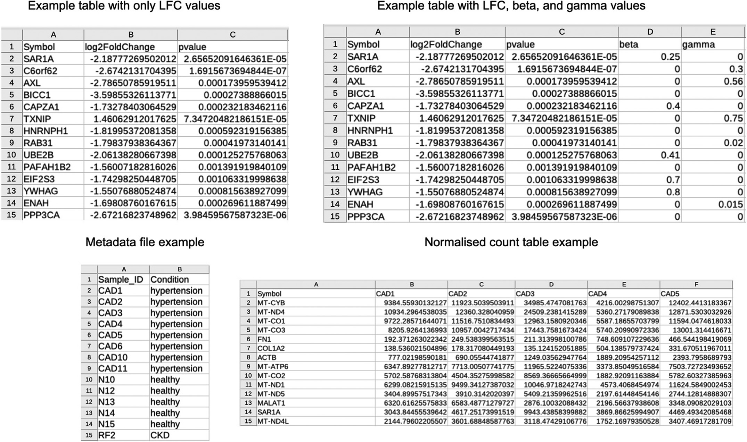

**Fig.1.**Examplesfortherequireddataformatswhichincludethenormalisedgeneexpressionvalues,logfoldchange(LFC)values,andthemetadatafile.

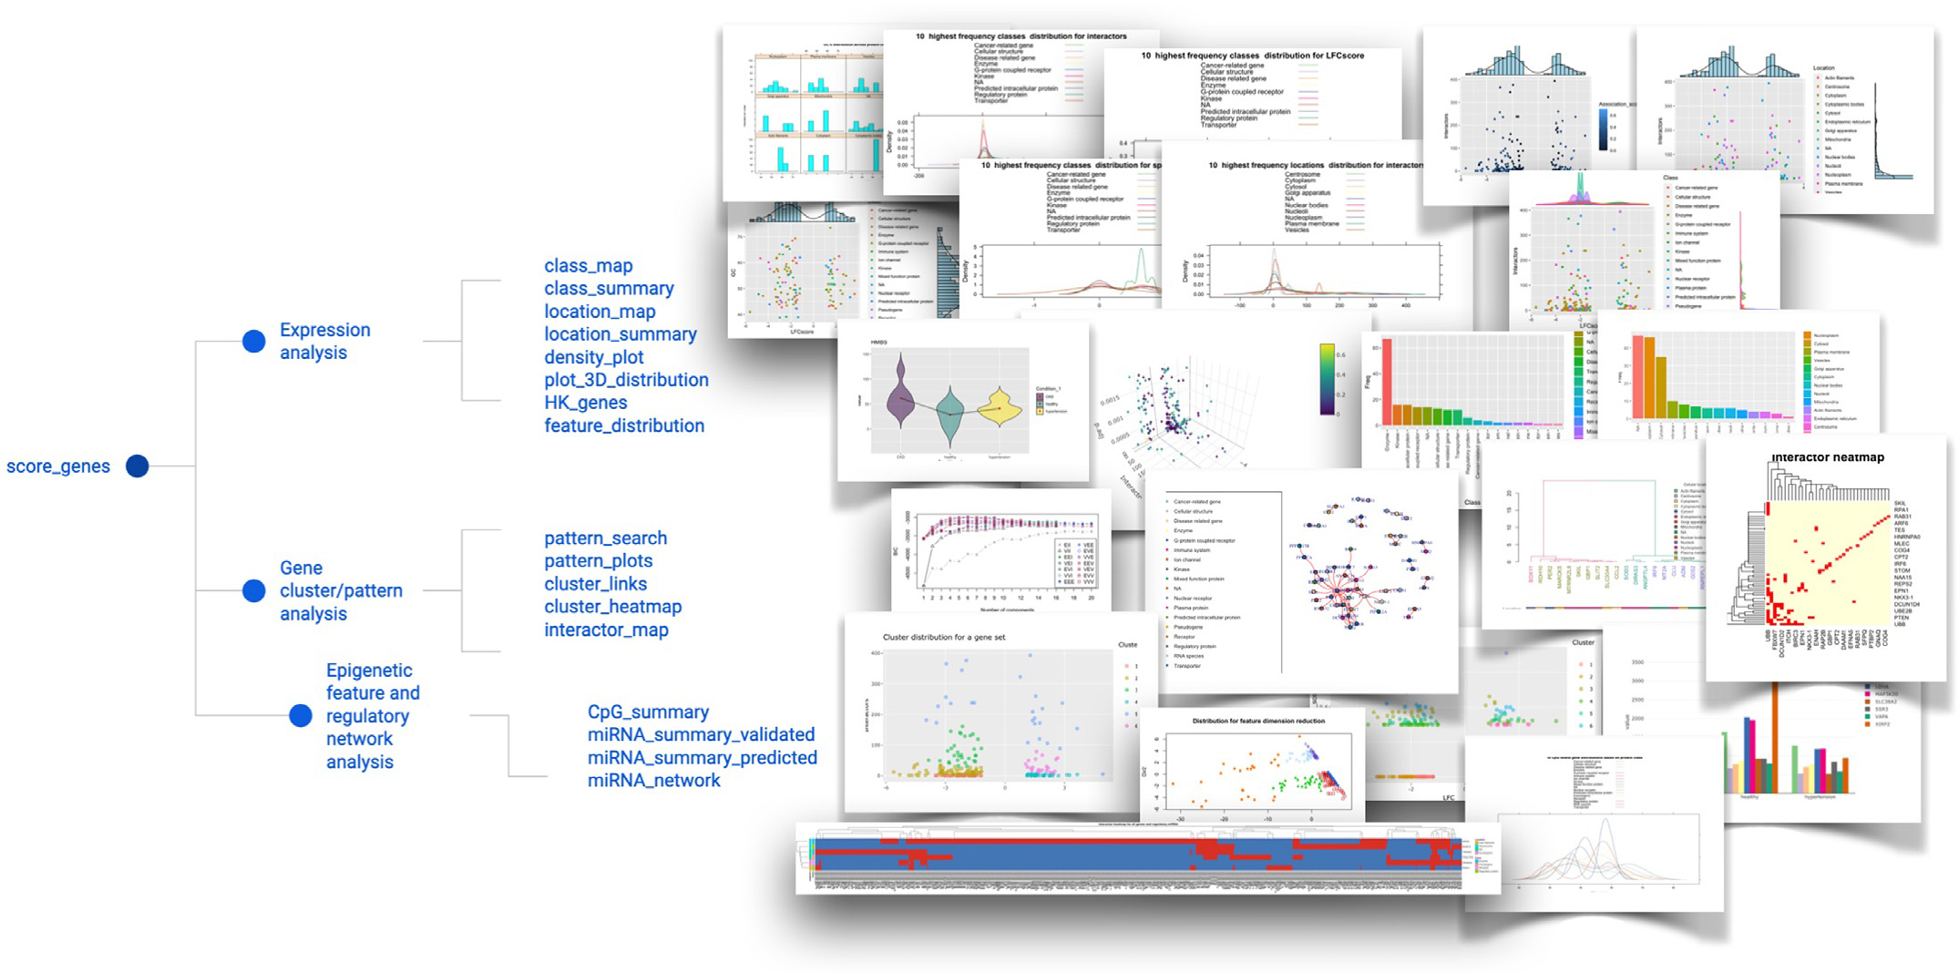

**Fig.2.**Schematicrepresentationofpackagefunctionsandspecificanalyses.

helpstomaximisethelikelihoodofdatapointassignments[4,12].Asa result,theusersdonotneedtohaveanextensiveknowledgetofine-tune theirGMMparametersastheprocessisstreamlinedforthem.

Thekeyanalyticalparameterinthemachinelearningpipelineand exploratoryanalysesisaspecificscore,namelyLFCscore,whichcanhave adifferentderivationdependingontheselectedparametersEqs.(1)–

2

*A.Kanapeckaite*  *ArtificialIntelligenceintheLifeSciences1(2021)100025*

Uniprot,andSTRINGDB[1,3,13].Forexample,*𝛼*asocscoreallowstoin-ferhowstronglyageneislinkedtoadiseaseorpathologicalphenotype rangingfrom0(nolink)to1(thestrongestassociation)Eq.(1)[13]. Similarly,*𝛼*speccaptureshowspecificageneiswhendescribingthe pathologyEq.(2)[13].Associationscoresarebasedondifferentcurated resourcesasdescribedearlier[13].Theusercanchoosefromdifferent typesofscores(“association_score”,“specificity_score”,orthegeomet-ricmeanofboth)whenselectingthetypeoftheequationforLFCscore. Scores*𝛽*celland*𝛾*protarethescaledvaluesforsinglecellandproteome data,respectively.Thatis,*𝛽*cellhastobeprovidedbytheuserifthey havesuchexperimentalinformationintegratedwhereagenevaluefrom asinglecelldataclusterisextractedusingapseudo-bulkdifferential geneexpressionapproach.TheLFCscoresfrompseudo-bulkdataneed tobescaledaccordingtotheEq.(4).Thesameapproachshouldbeap-pliedwhencalculating*𝛾*protforprotein(correspondinggene)values.

|  |  |
| --- | --- |
| LFCscore=LFC(1+αasoc+βcell+γprot LFCscoreequationwhereLFC-LogFoldChange,base2;*𝛼*asoc-adisease ) (1)  associationscore;*𝛽*cell-scaledsinglecellLFC;*𝛾*prot-scaledproteome LFC.  LFCscore=LFC(1+αspec+βcell+γprot LFCscoreequationwhereLFC-LogFoldChange,base2;*𝛼*spec-adisease ) (2)  specificityscore;*𝛽*cell-scaledsinglecellLFC;*𝛾*prot-scaledproteome LFC.  LFCscore=LFC  LFCscoreequationwhereLFC-LogFoldChange,base2;*𝛼*asocand*𝛼*spec ( 1+√(*𝛼*soc*𝛼*spec ) +βcell+γprot ) (3)  areintegratedusingageometricaveragescore;*𝛽*cell-scaledsinglecell LFC;*𝛾*prot-scaledproteomeLFC. | |
| LFCscaled=LFCgene∕LFCmedian | (4) |

*𝛽*cellor*𝛾*protscalingexamplewhereLFCgene-agenespecificvalueand LFCmedian-amedianvalueforallavailableLFCvaluesperspecificcon-ditionandgeneset.

*OmicInt*providesmanyothervaluabletoolstomaptheinterac-tomeusinginformationonthetargetcellularlocationorprotein class/functiontype.Inaddition,densityfunctionsallowforanexhaus-tiveassessmentofgenedistributionswhichmayhintatpotentialfunc-tionsordominantprocesseswithinaspecificcondition.Epigeneticfea-ture(CpGislands,GC%)andmiRNAexplorationtoolsalsoprovidead-ditionalinformationontheepigenomeandnon-codingregulomewhich mightberelevantforsomegenesandconditions,especiallyifahigher enrichmentofthesepatternscanbefound.Currently,theanalysesare onlyavailableforhumandatasets.Thesoftwarepackageisfreelydis-tributedviaGithubandCRANrepositoriestomaketheanalysesacces-sibletoresearchers[14,15].Githubenvironmentalsoprovidesoppor-tunitiestosubmitrequestsorsuggestionsandparticipateinfurtheral-gorithmdevelopment[14].

**2.Methods**

*OmicInt*packagearchitecture(Fig.2)isdividedintogeneexpression, genecluster/pattern,andepigeneticfeature/regulatorynetworkanaly-siswithadetailedvignettetoguidetheuser[14,15].Machinelearning pipelineisbasedonGaussianmixturemodelswhichisdesignedtoin-cludetheoptimalclusternumber(Bayesianinformationcriterion),auto-maticmodelfittingduringtheexpectationmaximisationphaseofclus-tering,model-basedhierarchicalclustering,aswellasdensityestimation anddiscriminantanalysis[4,12].Thepackageenablesadvancedoptions toperformauser-specifiedclusteringtousethedatainotherworkflows. *OmicInt*alsoretrievesdatafrommultipledatabasesbygeneratingcom-binedandcurateddatabaseimagesforeasieruse[1,3,13].Thepack-agewasbuiltusingfunctionalprogrammingprinciplesandtheanalyses werebenchmarkedusingthefollowingstudiesdistributedviaNCBIGEO database[16]:GSE160145,GSE3585,GSE26887,andGSE116250.

3

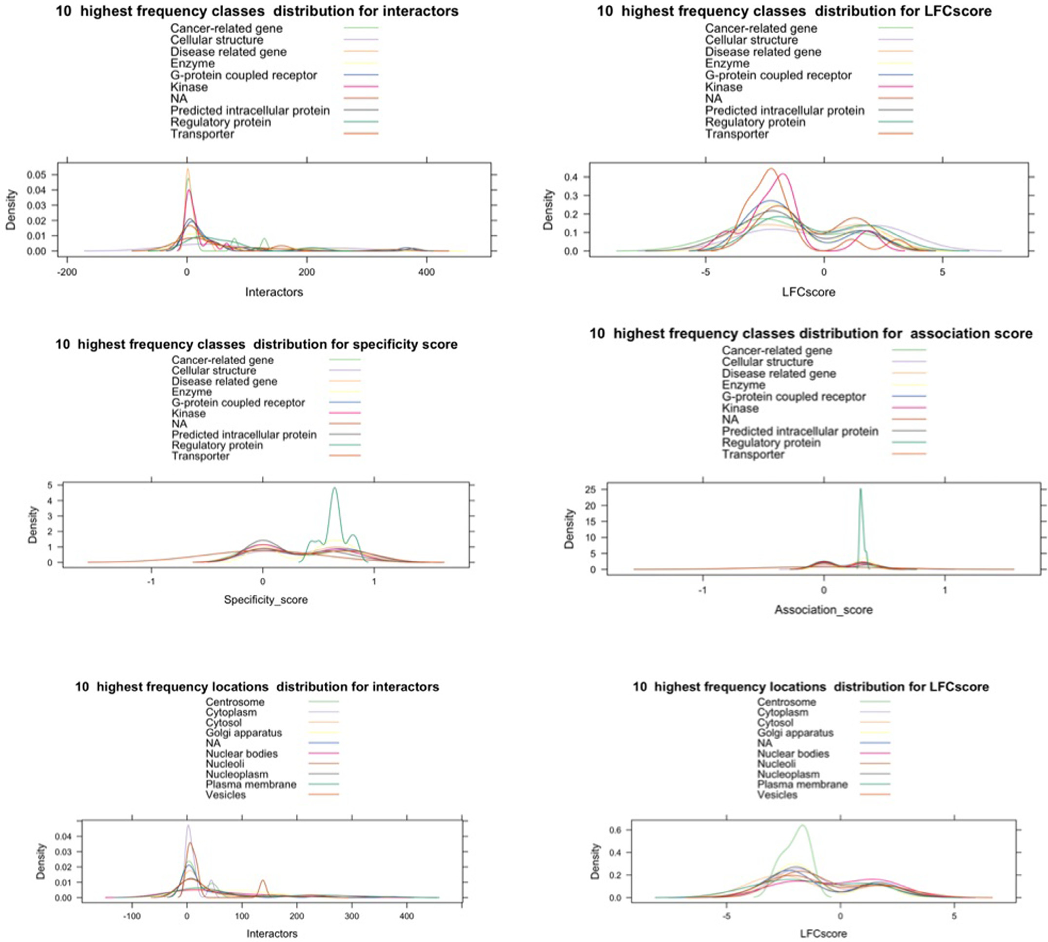

*A.Kanapeckaite*  *ArtificialIntelligenceintheLifeSciences1(2021)100025*

**Fig.3.**Densityplotexamplesfordifferentparameters.

Function*feature_distribution*alsoprovidesawaytovisualisemain featuredistributionsthroughdensityplotscombinedwithLFCscoreand interactornumberscatterplots(Fig.4).Theseplotsallowtoquickly assessifthereareanydependenciesbetweenLFCscoreandtheinteractor numbers.Suchplotsalsohelptoseeifanyobviousgeneclustersemerge. Inearlyanalysesthiscanaidinunderstandingwhethertheexpression isdependentonanycellularsiteorproteinclasswhichcouldsuggesta specificfunctionalenrichment.Thisfunctionmightissueawarningif thedatapointsweremissingortoofewfordensityplotting;however, itdoesnotaffecttheoverallvisualisation.



Function*plot_3D_distribution*allowstoexplore3Ddistributionsbe-tweenthenumberofinteractors,LFCscore,andp.adjvalues.Inaddition toprovidingadataparameter,theusercanselecthowtocolordata pointsdependingontheassociationorspecificityscore(e.g.,selecting“specificity”)(Fig.5).Thisanalysiscanhelpidentifyspecificclusters

4

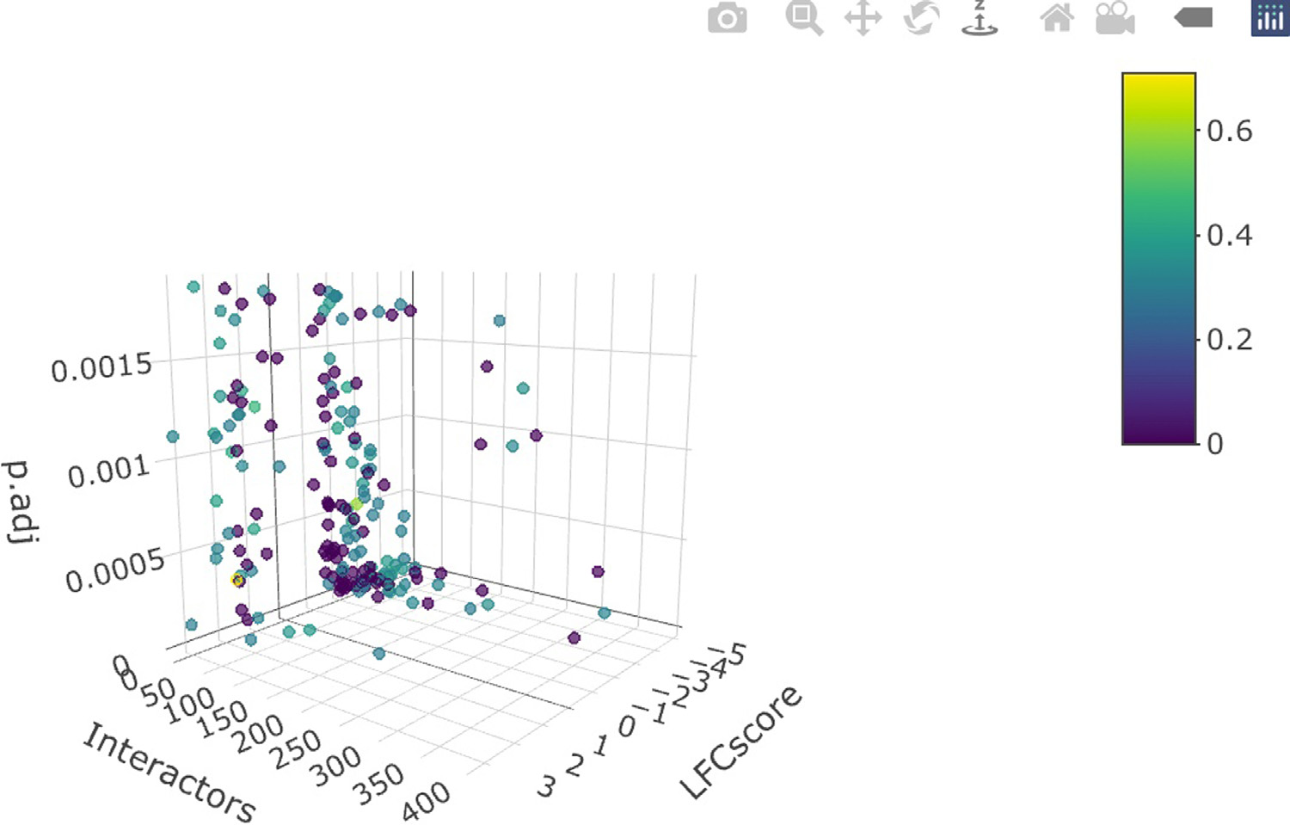

*A.Kanapeckaite*  *ArtificialIntelligenceintheLifeSciences1(2021)100025*

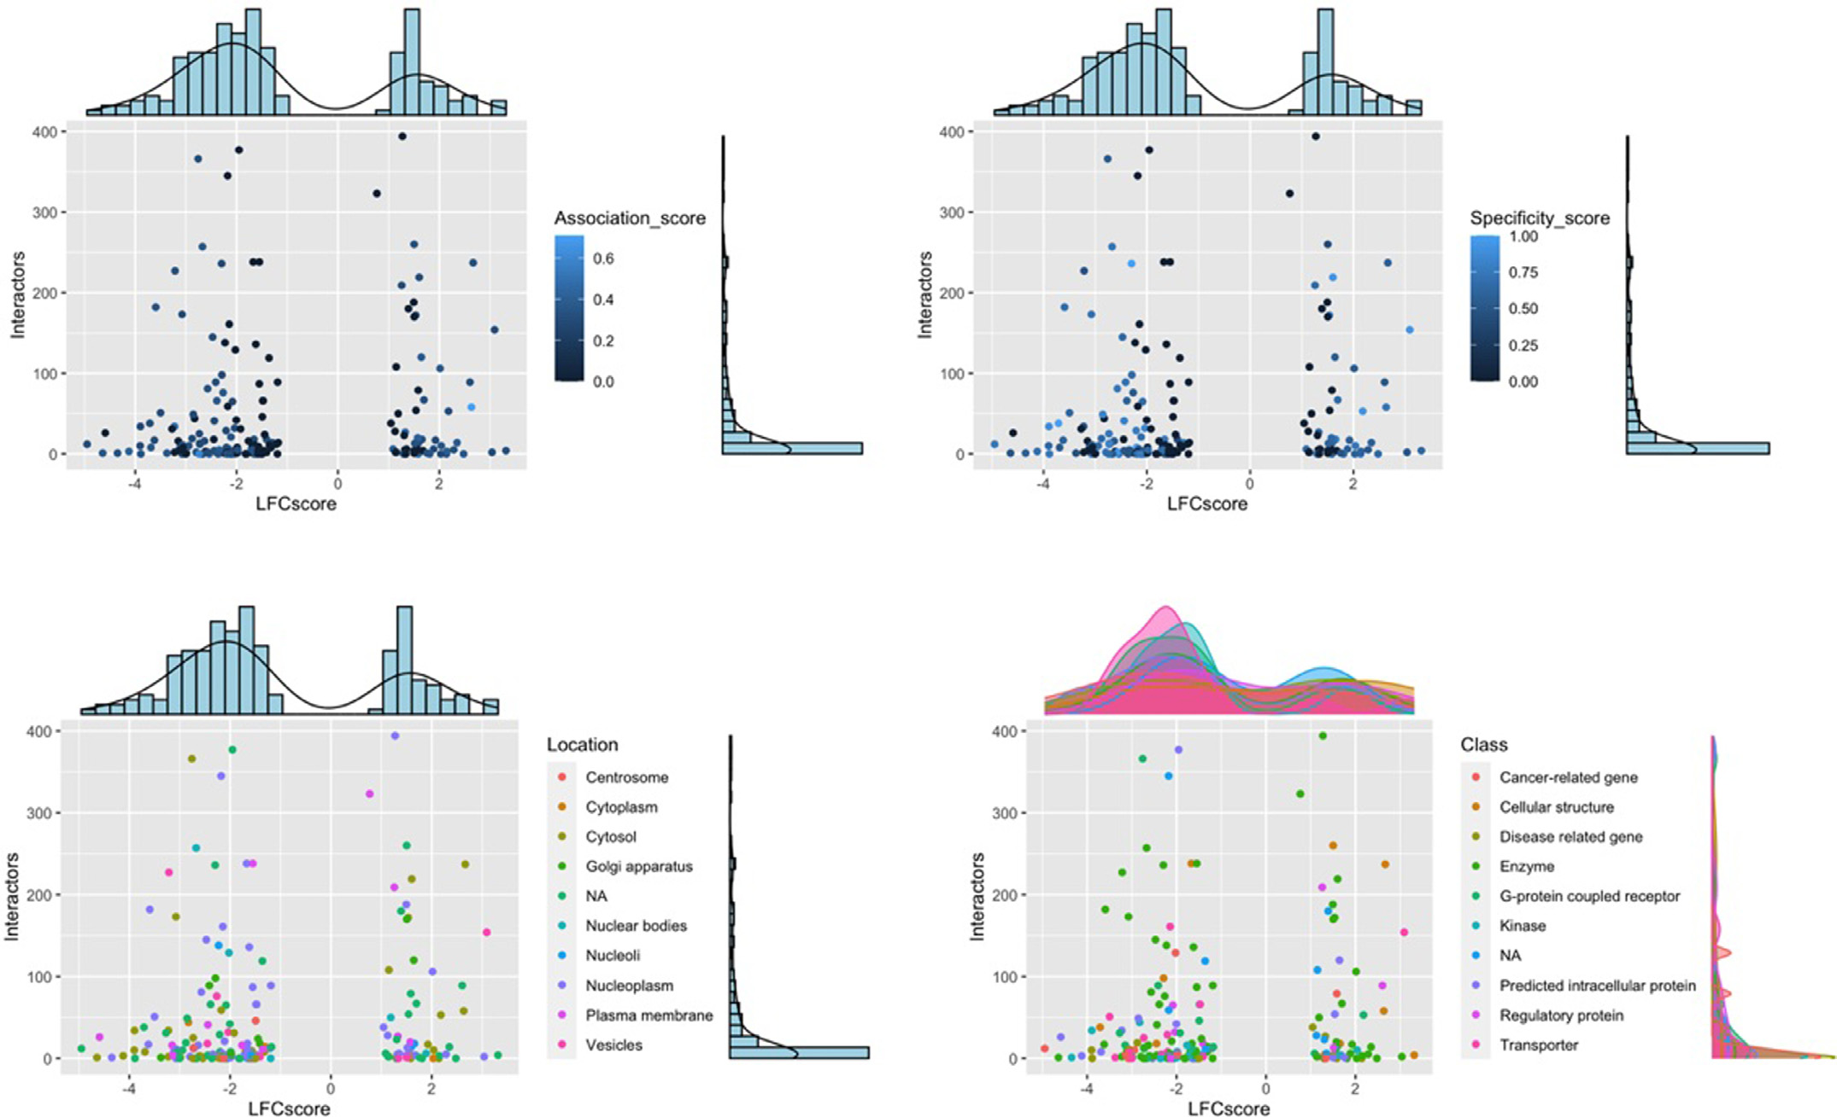

**Fig.4.**Featuredistributionplotexamples.

**Fig.5.**Interactive3Dfeaturedistribution.

Function*location_map*allowsthevisualisationofhowthehighestand lowestLFCscoregenesclusterbasedontheproteincellularlocationdata (Fig.7).Theusercanspecifythenumberofthetopandlowestgenesto consider.ThefunctionreturnsadendogramgeneratedbasedonLFCscore values.The“euclidean” methodisusedfordistancecalculationandthe“Ward.D2” method-forhclustgeneration.Genelabelsarecoloredto indicatemajorclusterswherethehclustgeneratedclusternumberis doubledtoselectformoresubgroups.Inaddition,toachieveafinersep-arationoflowerdendogrambranchesthefollowingequationisusedto settheheightforthecolordifferentiationofdifferentbranchesEq.(5).

5

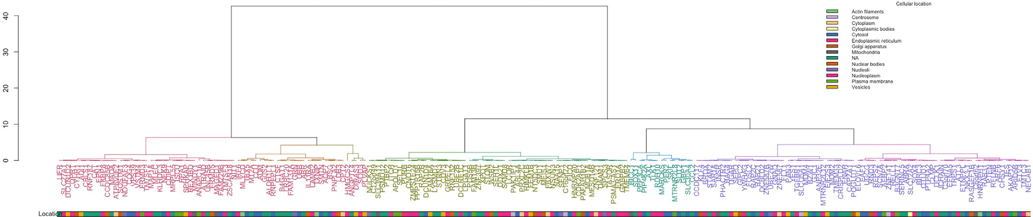

*A.Kanapeckaite*  *ArtificialIntelligenceintheLifeSciences1(2021)100025*

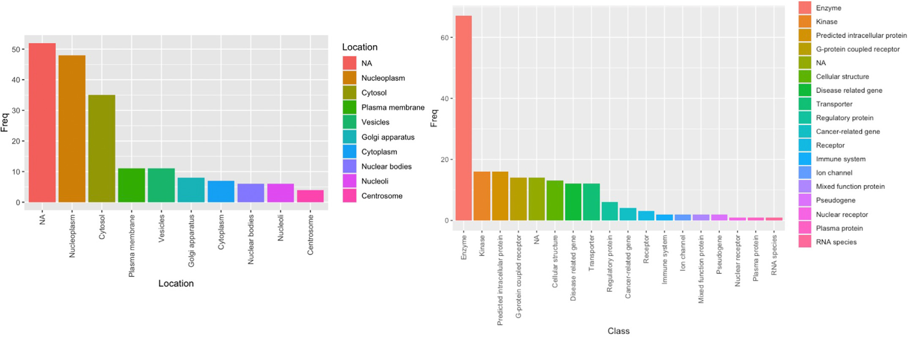

**Fig.6.**Locationandclasssummaryplots;NA– noclassificationavailable.

**Fig.7.**Dendogramwithmappedcellularlocationswherecolouredgenesymbolsrepresenttheidentifiedclustersandcolouredbranchesshowsmallersubclusters.

(Forinterpretationofthereferencestocolorinthisfigurelegend,thereaderisreferredtothewebversionofthisarticle.)

Similarly,thefunction*class_map*providesavisualisationofhowthe highestandlowestLFCscoregenesclusterbasedonproteinclass.Inaddi-tiontoadataframegeneratedby*score_genes*,thefunctionalsorequires a*num*parametertospecifythenumberofgenestoconsiderfromthe topupregulatedanddownregulatedgenes,ifthisoptionisnotselected allgeneswillbeused(Fig.8).



*HK_genes*functionprovidesaconvenientoverviewofthehouse-keepinggenesandallowstocheckifthesegenesvariedthrough-outconditions.Dependingonthenumberofconditionsseparate plotswillbegenerated(Fig.9).Inspectinghousekeepinggenescan helpunderstandiftherewasanysignificantvariationbetweensam-plegroupswhichmighthavearisenfrombiologicalortechnical variation.



*3.3.Geneclusterandexpressionpatternanalyses*

Function*cluster_genes*helpstoselectanoptimalnumberofclusters andamodeltobefittedduringtheEMphaseofclusteringforGMM.The functionprovidessummariesandhelpstovisualisegeneclustersbased ongenerateddatausing*score_genes*function.Weightedgeneexpression

6

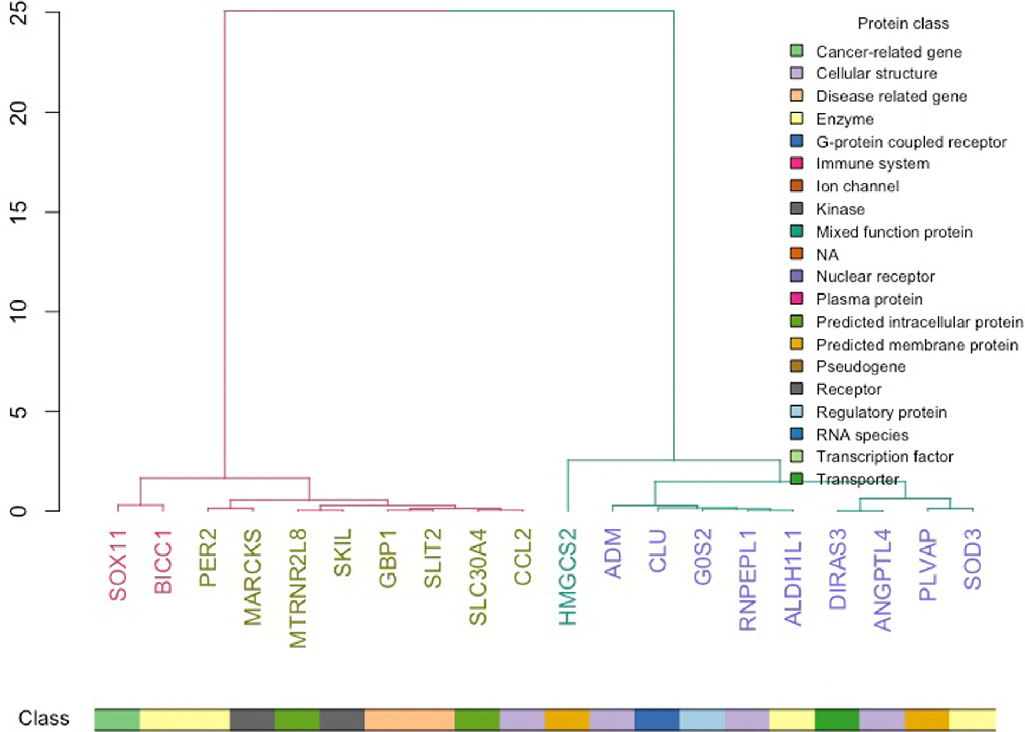

*A.Kanapeckaite*  *ArtificialIntelligenceintheLifeSciences1(2021)100025*

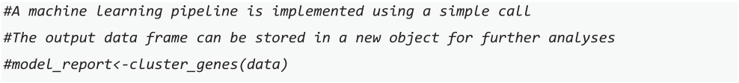

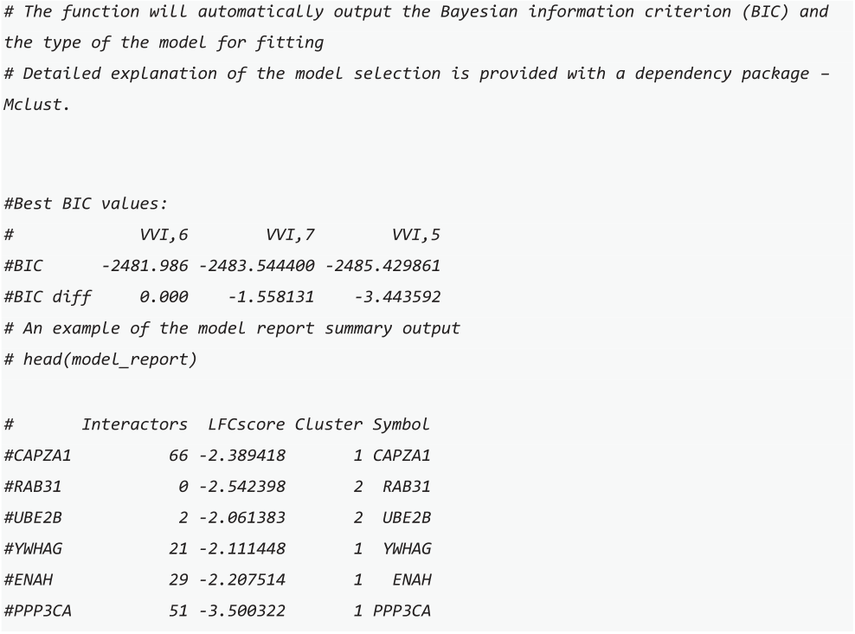

Function*cluster_links*providesthesameGaussianmixturemodeling pipelineas*cluster_genes*;however,insteadoftheinteractornumberclus-tering,theusercanselectaspecificdiseasescore*type*(thedefaultselec-tionis“association”).Thisparametercandefineeithertheassociation orspecificityforadisease,i.e.,ifthegenehasknownlinkstodisease

phenotypesandhowspecificitiswhendescribingapathology.Thefunc-tionalsoprovidesscatteranddimensionreductionplotstoanalysethe clustersandfeaturesinthedata.Anadditionaloutputisamodelreport summarisingtheclusterassignmentswhichcanbeusedinothermod-ellinganalyses.Thisinformationcanbeusedtocompareassociation andnetworksizeinfluencesfordifferentclustersandgeneexpression patterns.

Function*pattern_search*explorestheoccurrencesofspecificpatterns ingenesets.Thatis,itsearcheseachconditionforemergingpatterns (e.g.,ifmultipleconditionsareprovided)togroupgenesthatchanged inasimilarmanner(Figs.11and12).Thesearchalgorithmworksby firstgeneratingpotentialpatternstosearchdependingonthenumberof subclasses.Forexample,ifaconditionhasseveralsubclassesasinthe caseexample,whereCondition1hashealthy,hypertensive,andchronic kidneydisease(CKD)groups,thenpotentialpatternscenariosaregen-erated,e.g.,“up-up-up” or“down-up-down”.Followingthis,theoverall expressionforeachgeneiscalculatedusinggeometricmeanacrossall conditions,thisgivesabasallineagainstwhichanindividualgeneex-pressionvalueisweighedtodeduceifitisina‘up’or‘down’state.Com-paringagainstabaselineisamoreuniversalapproachthanperforming apairwisecomparisonswhichmaynotbeeffectiveformultiplesub-classesorcomplexinteractions.Inaddition,averagingexpressionusing ageometricmeanmethodprovidesabaselineforcomparisonstaking intoaccountalltheextremevalueswhichmightresulteitherfrombio-logicalortechnicaleffects.Itisimportanttonotethattakingageometric meanmightnotbeoptimalinallcases,butinabalancedexperiment itshouldprovideadditionalinformationforthedownstreamanalyses. Thefunctionreturnsasummaryofhowmanygenesareidentifiedfor eachpatterntypeacrossconditions.

**Fig.8.**Dendogramwithmappedproteinfunctionswherecolouredgenesymbolsrepresenttheidentifiedclustersandcolouredbranchesshowsmallersubclusters. (Forinterpretationofthereferencestocolorinthisfigurelegend,thereaderisreferredtothewebversionofthisarticle.)

7

*A.Kanapeckaite*  *ArtificialIntelligenceintheLifeSciences1(2021)100025*

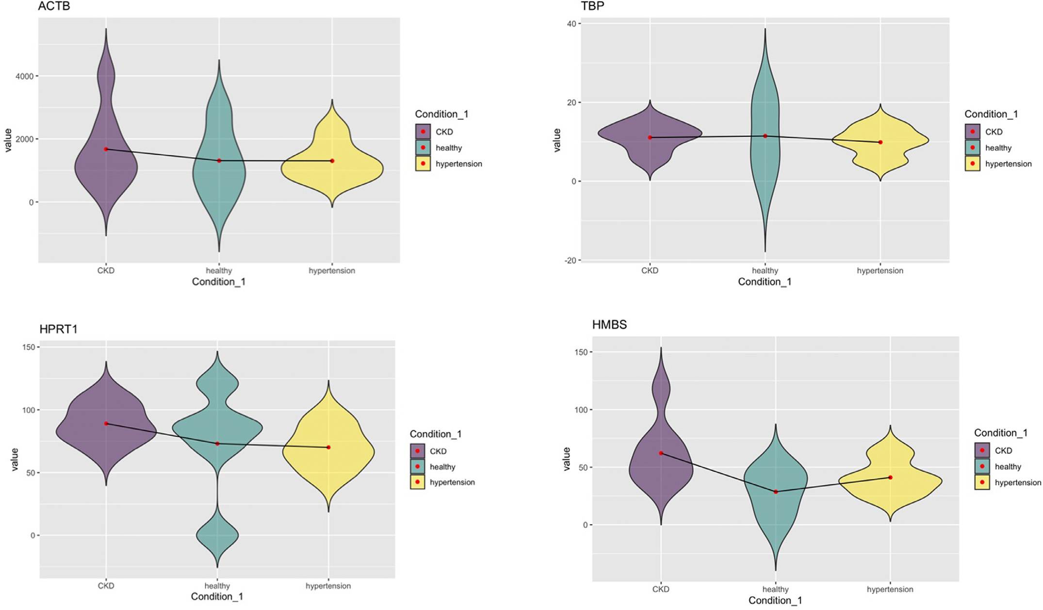

**Fig.9.**Anexampleofthehousekeepinggenedistribution.Theredmarkerindicatesthemeanforthegroupandviolinplotsallowtoassessglobaldistribution patterns.CKD– chronickidneydiseasepatientgroup,healthy– healthypopulationgroup,andhypertension– hypertensivepatientgroup.(Forinterpretationofthe referencestocolorinthisfigurelegend,thereaderisreferredtothewebversionofthisarticle.)

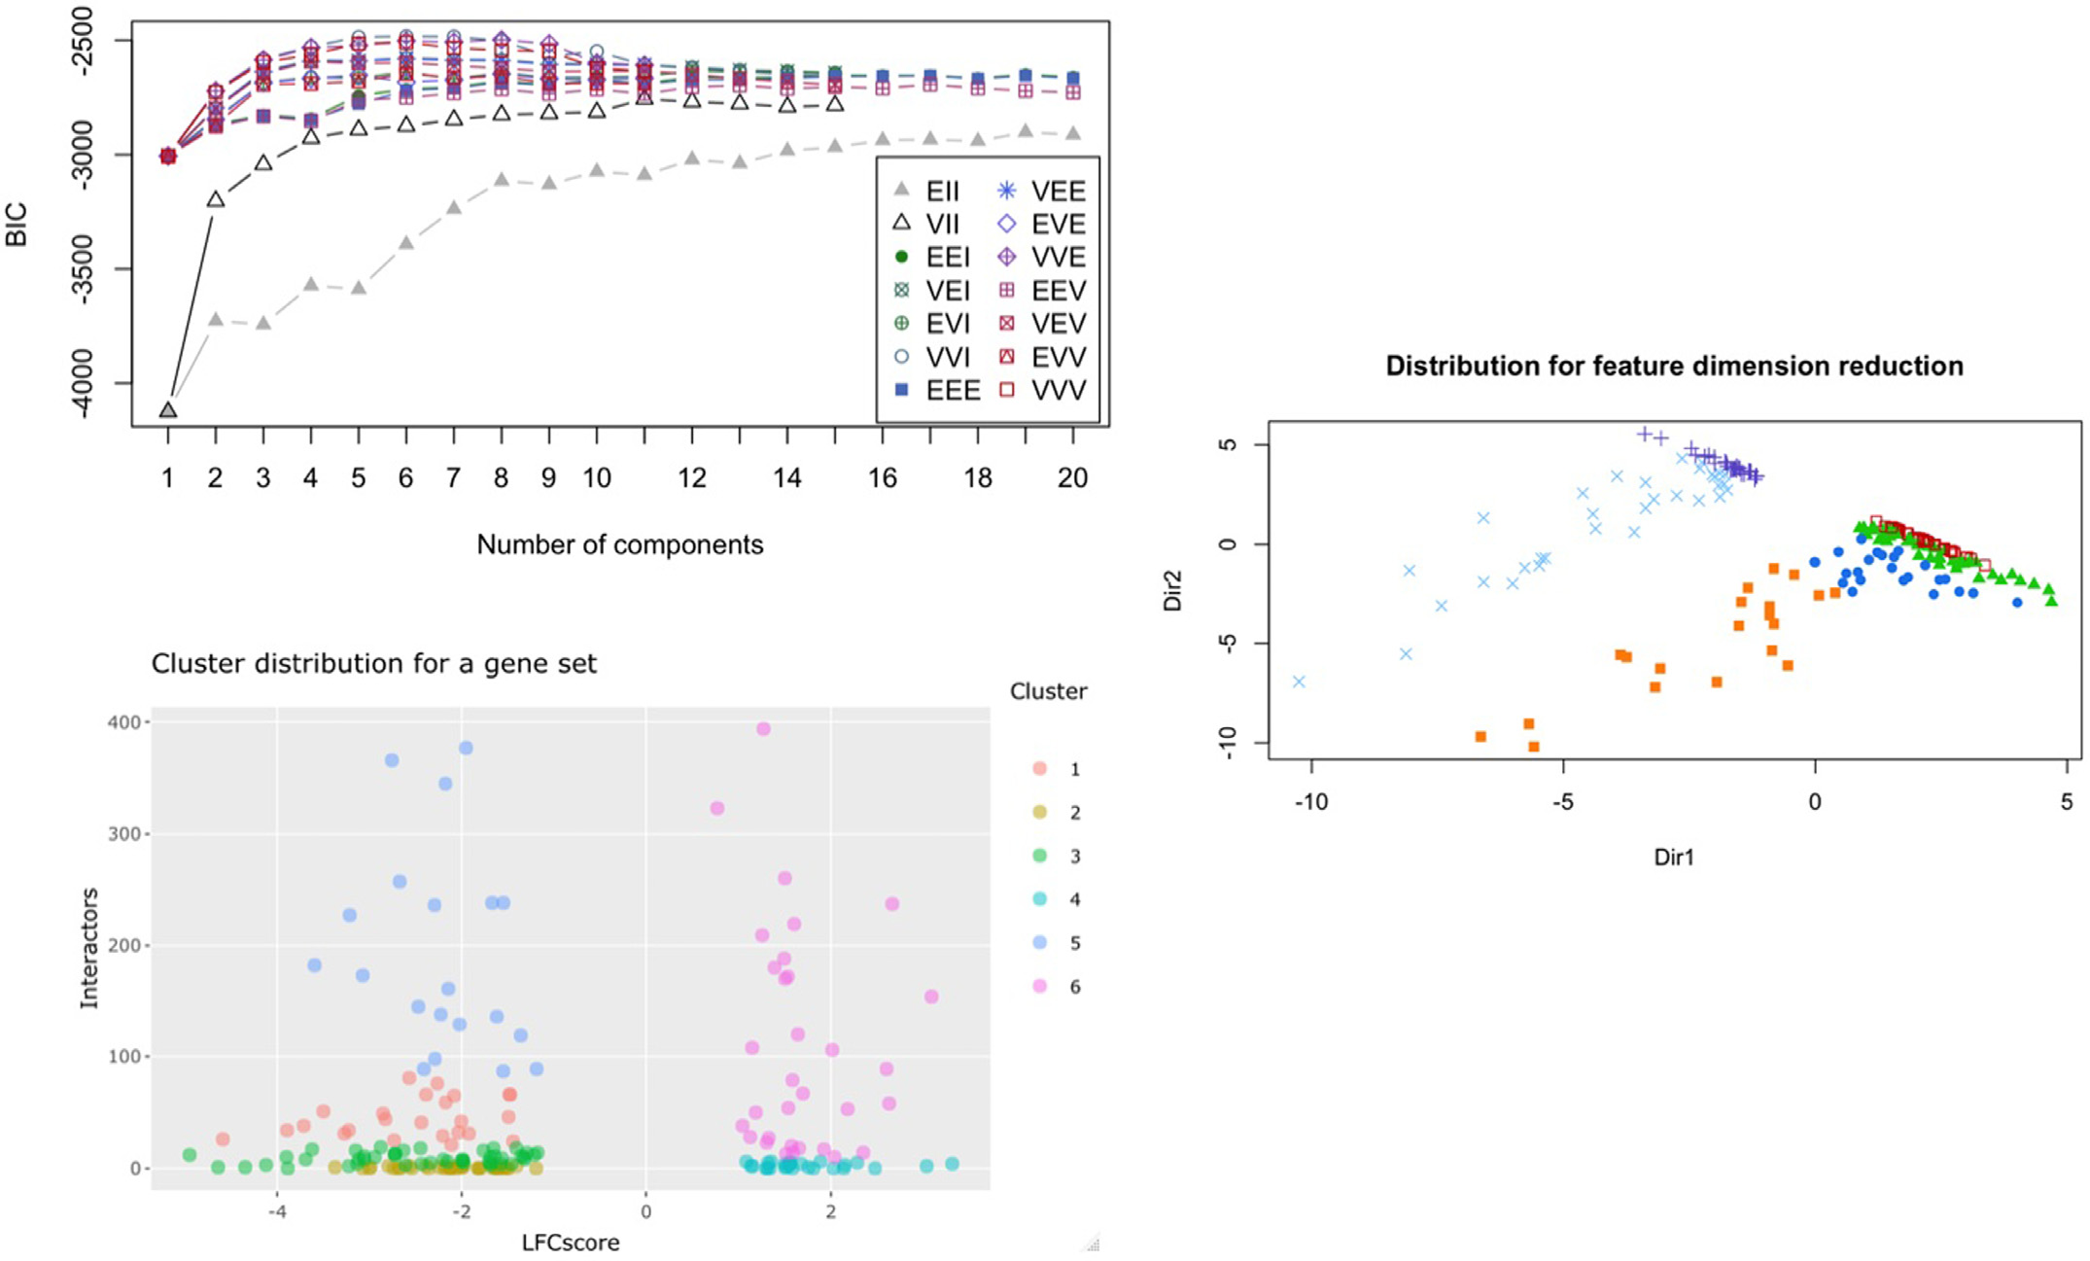

**Fig.10.**GMManalysisexamplesshowingtheBayesianinformationcriterion(BIC)evaluationandmodeltypeprediction,clusteringanalysis,aswellasthedimension reductionanalysisbasedontheintrinsicvariabilitywithinthedata.

8

*A.Kanapeckaite*  *ArtificialIntelligenceintheLifeSciences1(2021)100025*

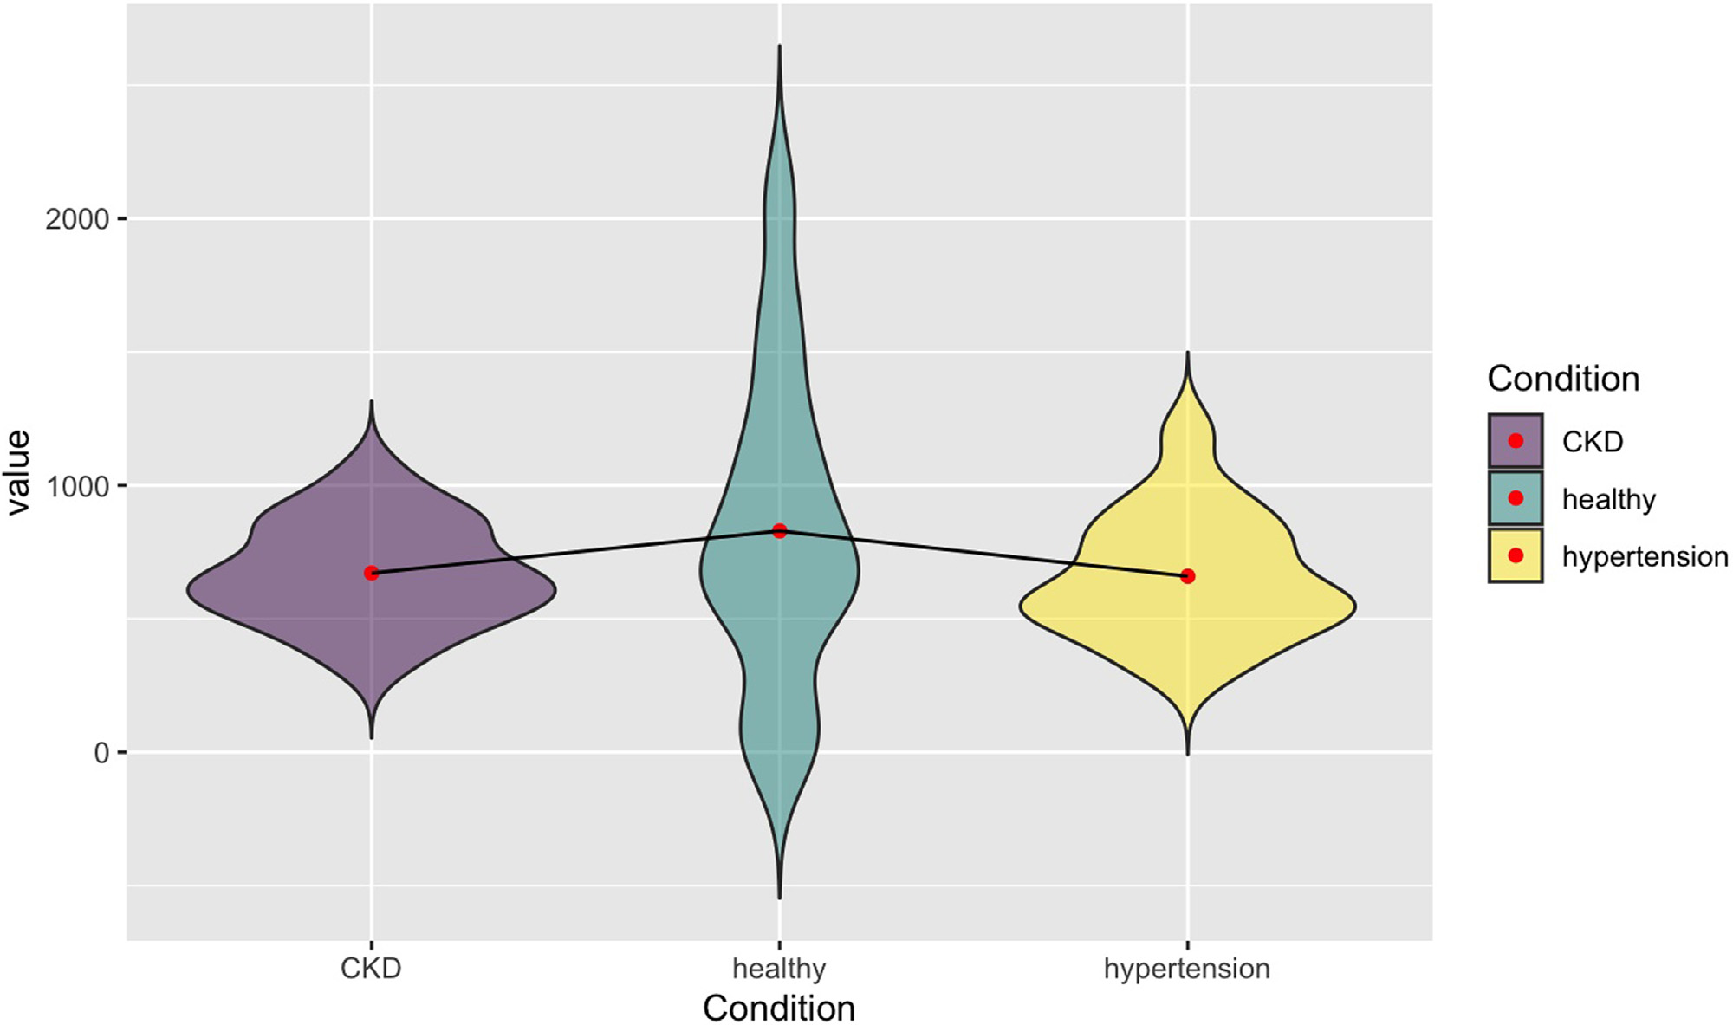

**Fig.11.**Genedistributionpatternsforaspecificexpressionpatternsubsetwheremeanvalues(signifiedwitharedpoint)areconnectedtohighlightthepattern featureswithrespecttothemeanvalue(theexampleisfroma“down-up-down” patterngroup).CKD– chronickidneydiseasepatientgroup,healthy– healthy populationgroup,andhypertension– hypertensivepatientgroup.(Forinterpretationofthereferencestocolorinthisfigurelegend,thereaderisreferredtotheweb versionofthisarticle.)

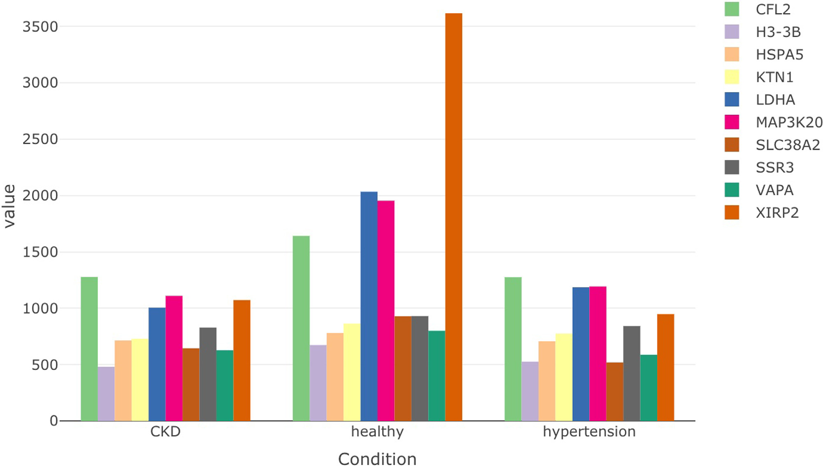

**Fig.12.**Individualgenedistributionswhenselectingaspecificexpressionpatternandrange(theexampleisfroma“down-up-down” patterngroup).CKD– chronic kidneydiseasepatientgroup,healthy– healthypopulationgroup,andhypertension– hypertensivepatientgroup.

9

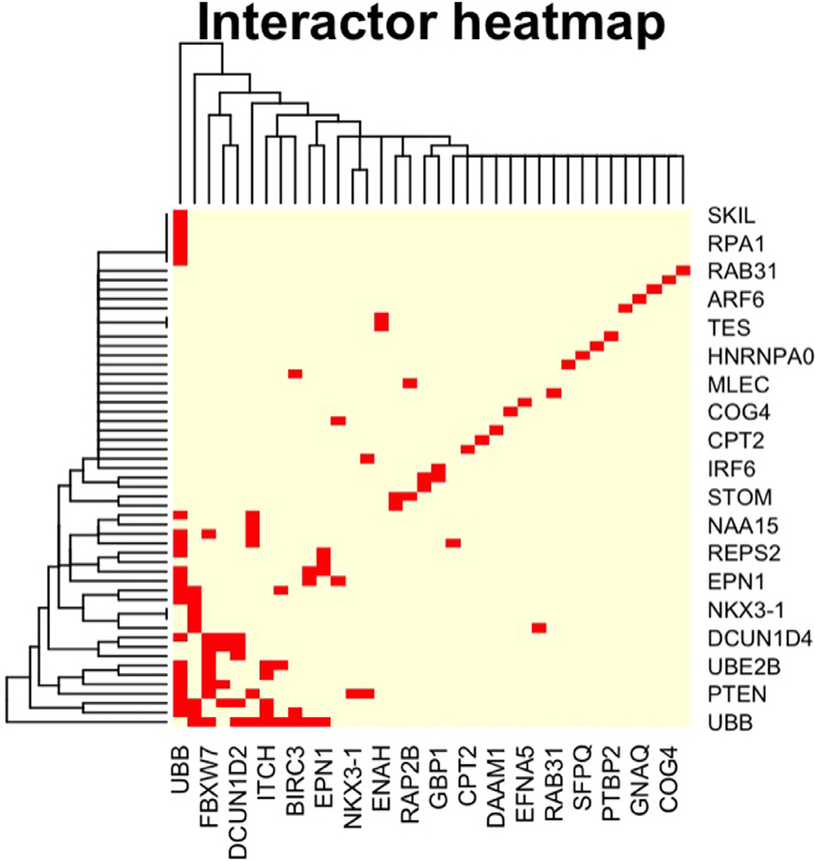

*A.Kanapeckaite*  *ArtificialIntelligenceintheLifeSciences1(2021)100025*

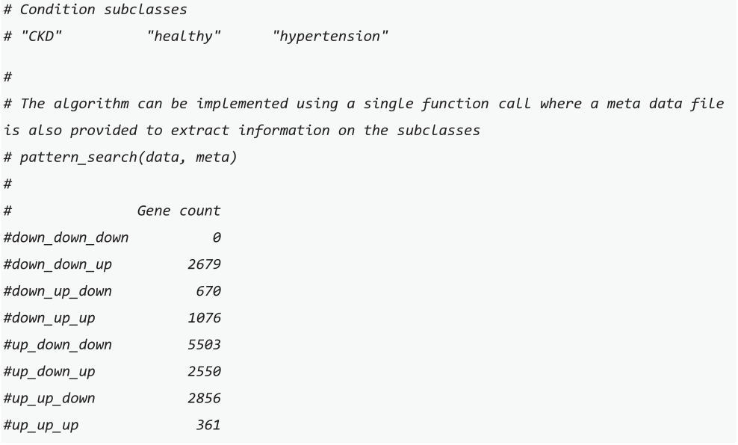

Thereturnedgenelistcontainsgroupsofgenesforthedifferenttypes   
ofpatterns.Apatternofinterestcanbeselectedtofurtherexplorethe   
genesthatchangedtheirexpressioninaspecificmanner.

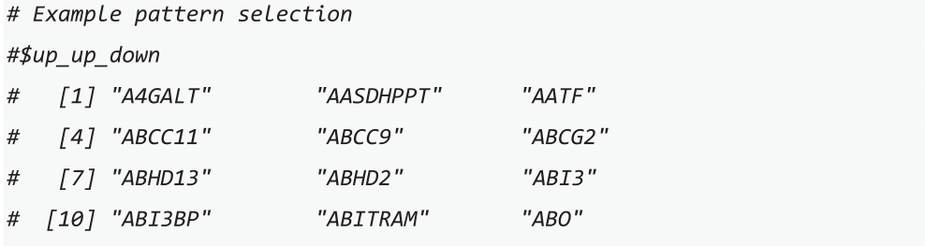

Thisanalysiscanbefollowedby*pattern_plots*whichallowstoex-ploredistributionsforaselectedpatterngroup.Theusermustpro-videasubsetteddataframeandlow/highparameterstoselectaspe-cificrange.Theselectionisneededbecauseinsomeinstancesthe expressionvaluesmightdiffersignificantlyandvisualisingalldata pointswillpreventexploringanymeaningfulsubsets.Theoutputsal-lowtoevaluatehowgenesdistributeinasubsetfordifferentconditions (Fig.11)andhowindividualgenevaluesvaryinaselectedsubgroup (Fig.12).

Function*cluster_heatmap*usestheinformationminedfromthe STRINGdatabase[3]tomapexperimental,referenced,andinferredin-teractionstoseeifthereareanyinteractorsinthesetofsignificantly changedgenes.Thisheatmapfunctionprovidesaclusteredvisualisa-tionofallthegenesthathavesharedinteractions(Fig.13).Thisinfor-mationallowstoquicklyassesshowmanygenesinaspecificcondition thatchangedsignificantlymightbepartofthesameregulatorycluster. Suchdatacanhelpselectspecifictargetsdependingonthetherapeutic strategy.

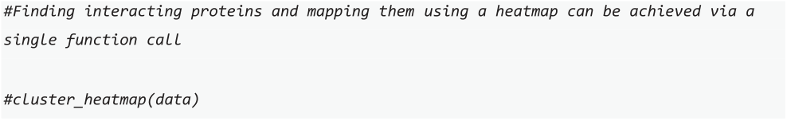

Function*interactor_map*helpstovisualisetheinformationmined fromtheSTRINGdatabase[3]andmapdirectandreferencedinterac-tionstoseeifthereareanyinteractorsinthesetofsignificantlychanged genesandhowtheyarelinked.Thisvisualnetworkisanalternativefor aheatmapwithadditionalinformationonthefunctionalgenefeatures (Fig.14).



10

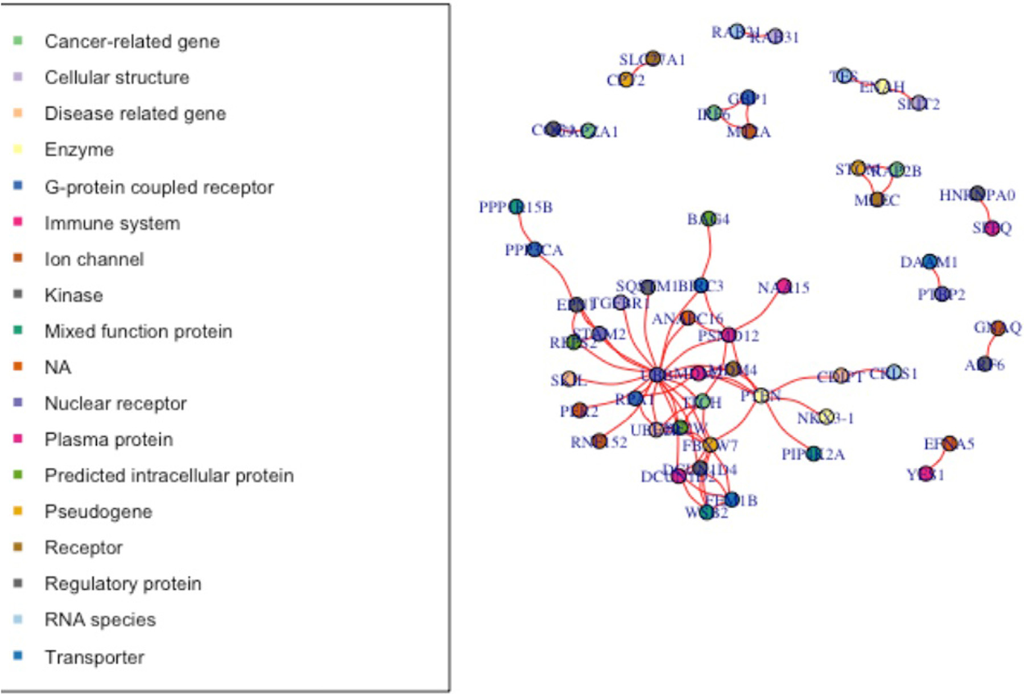

*A.Kanapeckaite*  *ArtificialIntelligenceintheLifeSciences1(2021)100025*

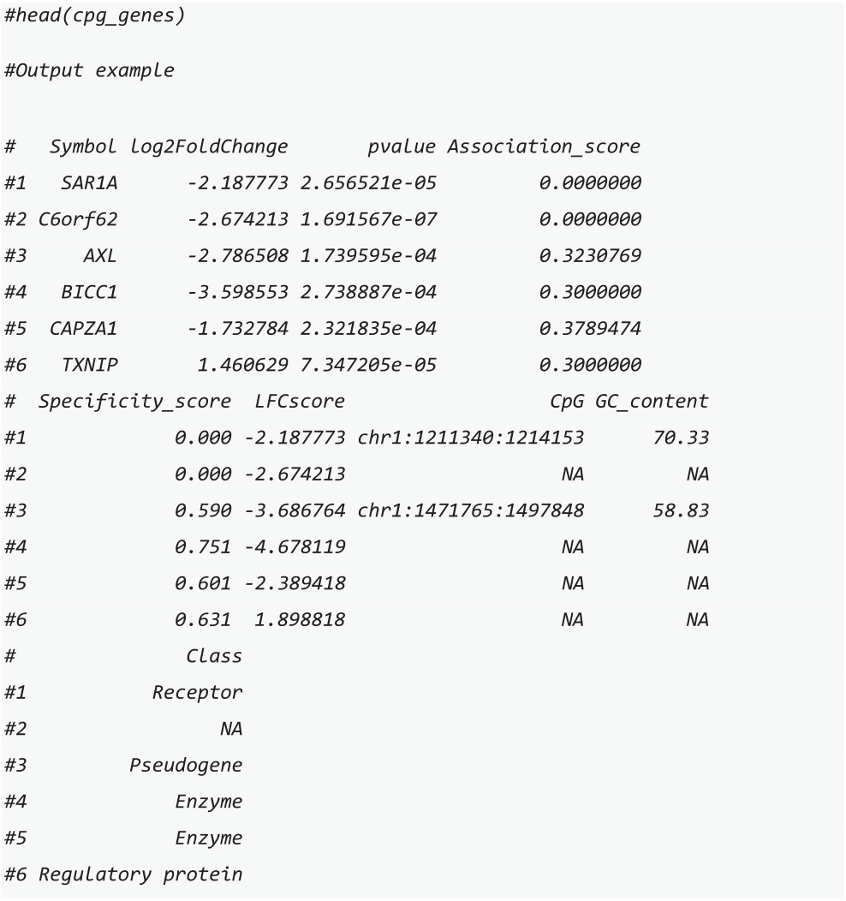

Function*miRNA_summary_predicted*issimilartotheearlierfunc-tion;however,itallowstocheckhowmanyofthedifferentiallyex-pressedgeneshavepredictedmiRNAs.Theinformationiscollectedfrom miningmultipledatab[asesthatus](https://mirtarbase.cuhk.edu.cn/~miRTarBase/miRTarBase_2022/php/index.php)e[algor](https://genie.weizmann.ac.il/pubs/mir07/mir07_prediction.html)i[thmst](https://pictar.mdc-berlin.de/)o[infer](http://c1.accurascience.com/miRecords/)likely[miRNAs.](https://www.ncbi.nlm.nih.gov/pmc/articles/PMC5187787/) [Thedatabasesi](https://www.ncbi.nlm.nih.gov/pmc/articles/PMC3692048/)[nclude](http://mirdb.org/)[m](https://mirtarbase.cuhk.edu.cn/~miRTarBase/miRTarBase_2022/php/index.php)[iRTarBa](https://www.ncbi.nlm.nih.gov/pmc/articles/PMC1370898/)[s](https://mirtarbase.cuhk.edu.cn/~miRTarBase/miRTarBase_2022/php/index.php)[e,PITA,](http://www.targetscan.org/vert_72/)[PicTar](https://pictar.mdc-berlin.de/)[,miRecor](https://www.ncbi.nlm.nih.gov/pmc/articles/PMC3293225/)[ds](http://c1.accurascience.com/miRecords/),[miRanda](https://www.ncbi.nlm.nih.gov/pmc/articles/PMC5187787/), [DIANA-microT](https://www.ncbi.nlm.nih.gov/pmc/articles/PMC3692048/),[miRDB](http://mirdb.org/)[,](https://mirtarbase.cuhk.edu.cn/~miRTarBase/miRTarBase_2022/php/index.php)[TarBase](https://www.ncbi.nlm.nih.gov/pmc/articles/PMC1370898/)[,](https://mirtarbase.cuhk.edu.cn/~miRTarBase/miRTarBase_2022/php/index.php)[TargetS](http://www.targetscan.org/vert_72/)[can,Mi](https://pictar.mdc-berlin.de/)[croCosm](https://www.ncbi.nlm.nih.gov/pmc/articles/PMC3293225/)[,a](http://c1.accurascience.com/miRecords/)n[dElMMo](https://www.ncbi.nlm.nih.gov/pmc/articles/PMC5187787/). [Thefunctional](https://www.ncbi.nlm.nih.gov/pmc/articles/PMC3692048/)s[oreturn](http://mirdb.org/)[sadatat](https://www.ncbi.nlm.nih.gov/pmc/articles/PMC1370898/)a[blewithmi](http://www.targetscan.org/vert_72/)[RNAinform](https://www.ncbi.nlm.nih.gov/pmc/articles/PMC3293225/)ation[thatcan](https://academic.oup.com/nar/article/44/1/24/2499630) beusedindesigningRNAinterferenceexperiments.

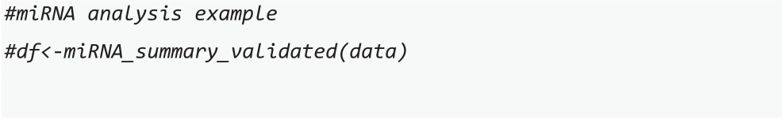

Function*miRNA_network*allowstoexamineifagenesethasshared regulatorymiRNAs(Fig.19).Thisfunctioncouldbeespeciallyusefulas itcouldhelpexploringthenon-codinglayeroftheregulatorynetwork. Thisinformationcanaidinstudyinghowsomegenesarecontrolledby severalmiRNAsanddetectadditionallinksbetweengenesthatchanged expression.Moreover,usingmiRNAanalysescanbeappliedindesign-ingRNAinterferencestudiestoselectthemostoptimalinterferencese-quences.miRNAcontentinformationcanbeaccessthroughthefunc-tion’soutput.

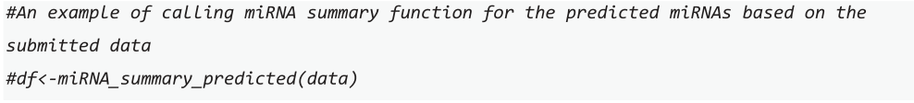

**4.Discussion**

*OmicInt*packageprovidesauniquecombinationoffunctionsand toolsforresearcherstoexploregeneexpressiondatasets.Aspecialfocus ofthepackageisalsomakingmachinelearning,specificallyGaussian mixturemodels[4–6],moreaccessibletotheresearchersthatdonot haveabackgroundintheML/AIfield.Inaddition,thelackoftoolsfor theexplorationofthecomplexexpressomedatahighlightedtheneedfor suchasetofbioinformaticstools.Forexample,commercialsolutions, suchasClarivateanalytics[7],areveryexpensiveandcannotbeeasily usedbyindividualresearchers.Freelyavailabletools,namelyGeneMA-NIAorCytoscapeplatforms[9–11,20],donotpermitmachinelearning applicationsorcomplexregulomeintegration.Asaresult,the*OmicInt* packagewasdevelopedforadvancedanduser-friendly*omics*analyses.

**Fig.14.**Interactormapexamples.   
11

*A.Kanapeckaite*  *ArtificialIntelligenceintheLifeSciences1(2021)100025*

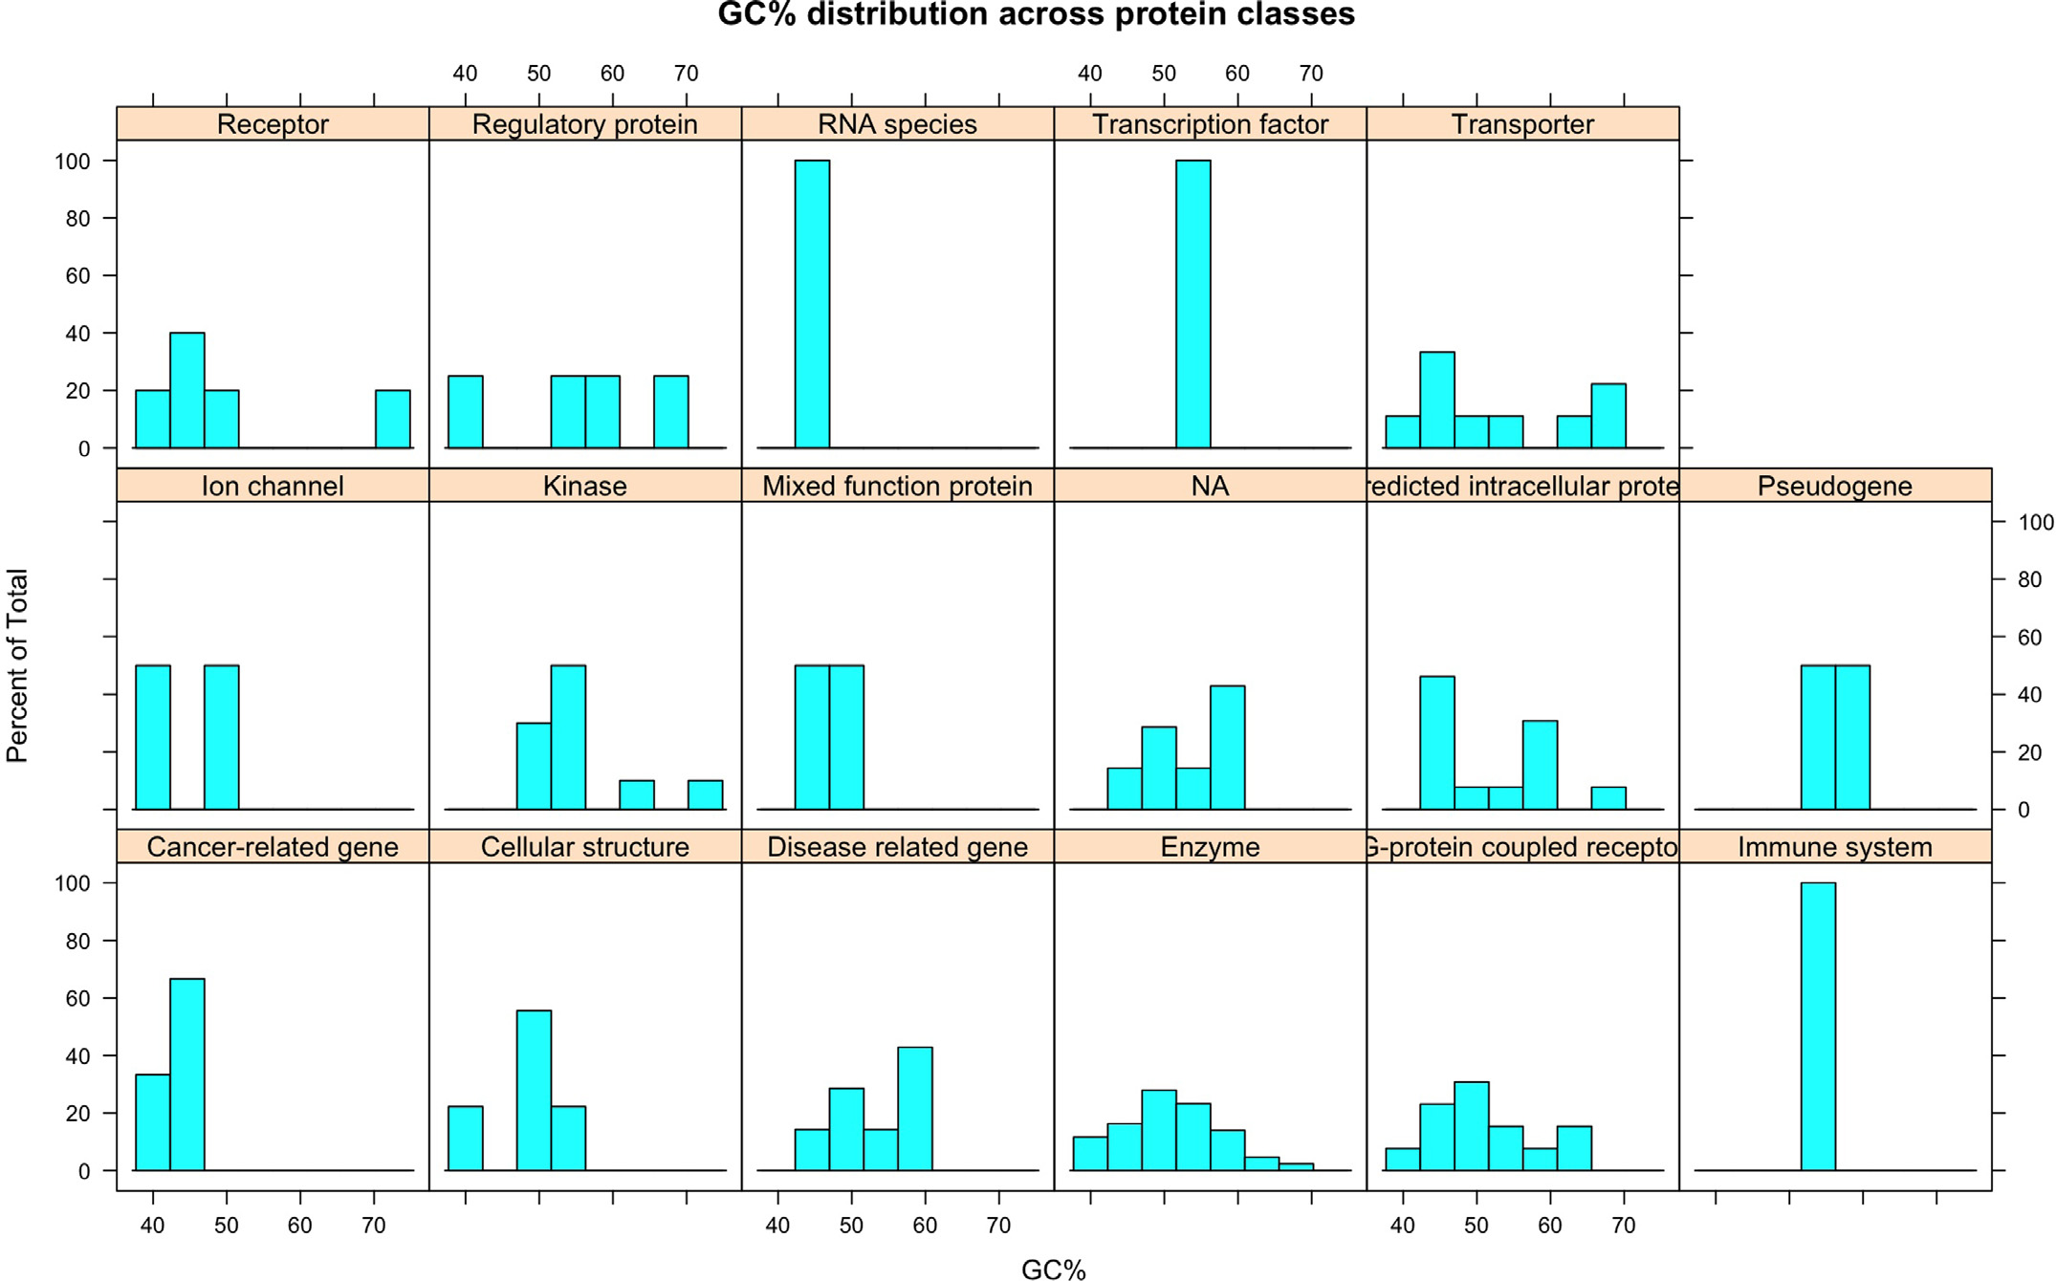

**Fig.15.**CpGsummaryexampleswheretheGC%contentdistributionisshownfordifferentproteinclasses.

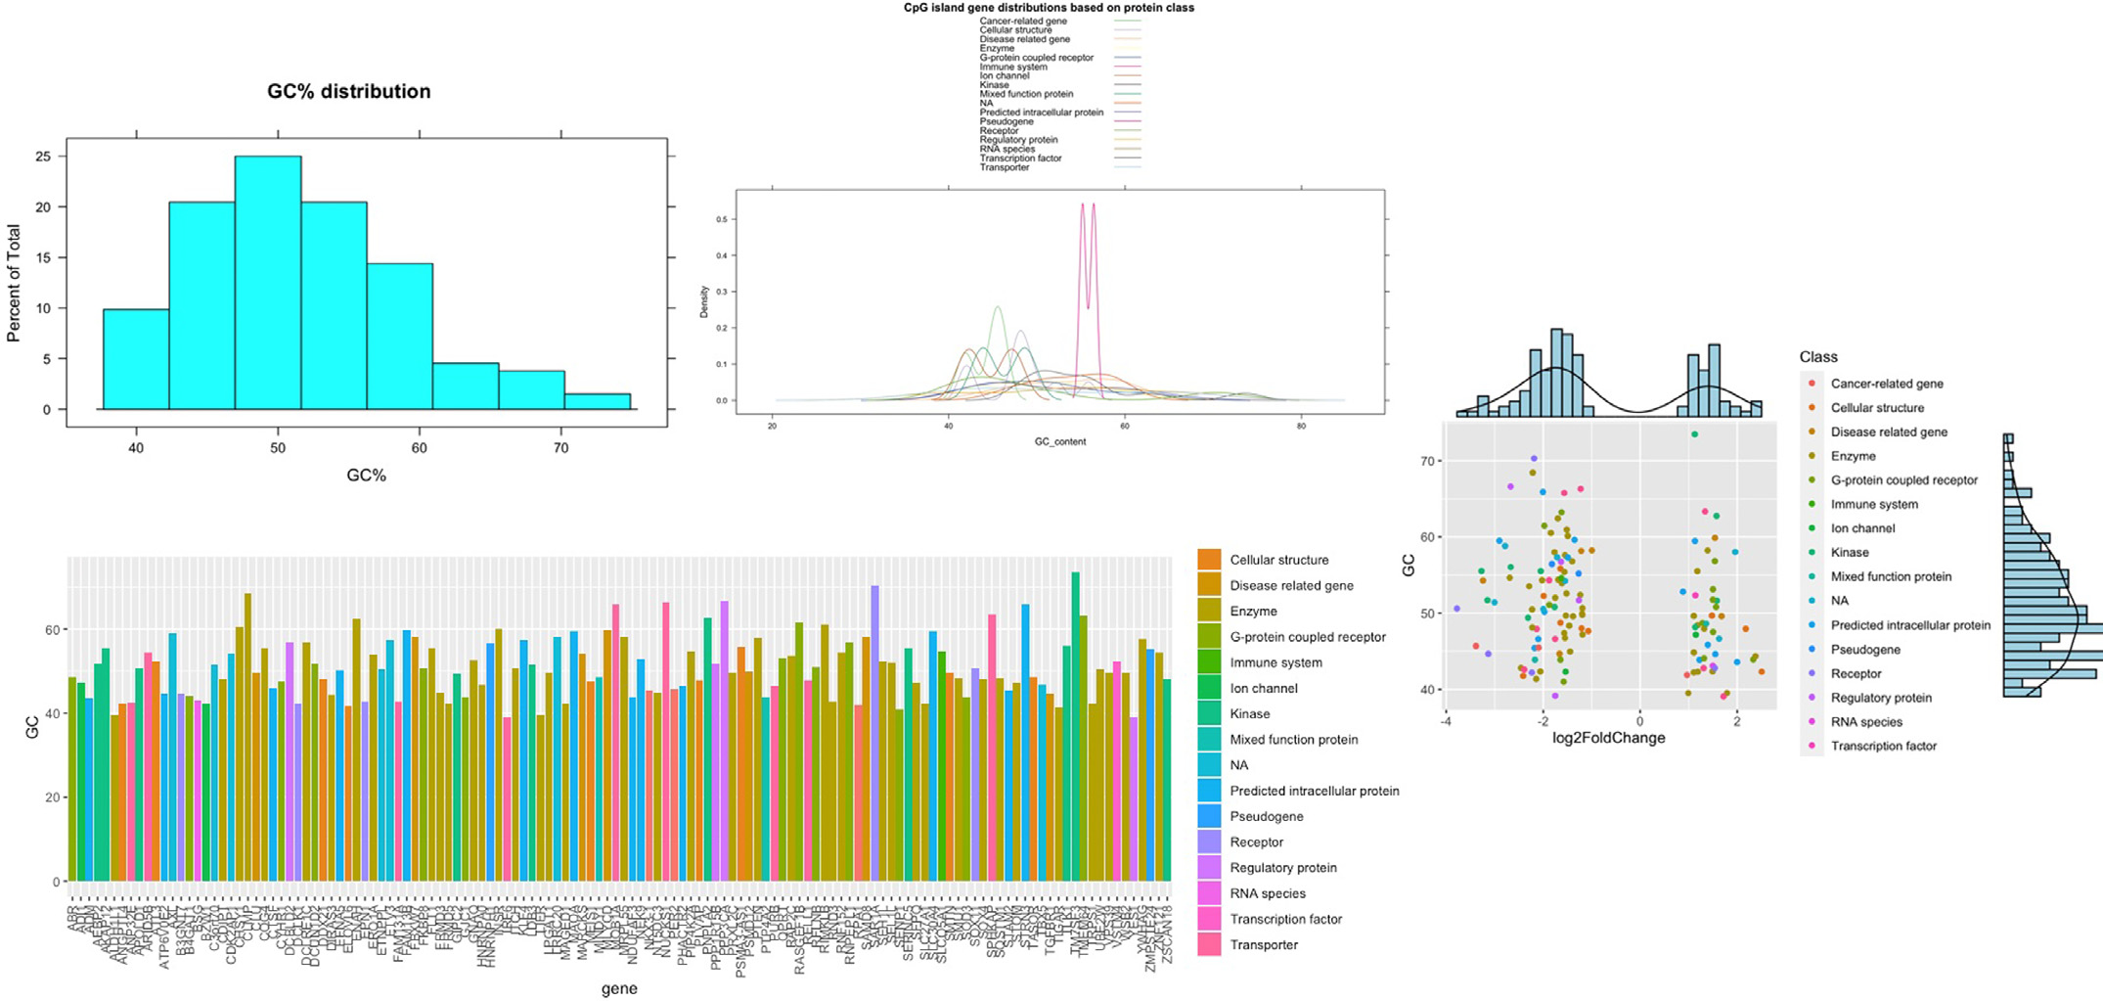

**Fig.16.**CpGsummaryexampleswhereGC%profilesareshownfordifferentgenesandtheircorrespondingproteinclasses.Summarydensityplotsandhistograms arealsoshownfordifferentparameters.

12

*A.Kanapeckaite*  *ArtificialIntelligenceintheLifeSciences1(2021)100025*

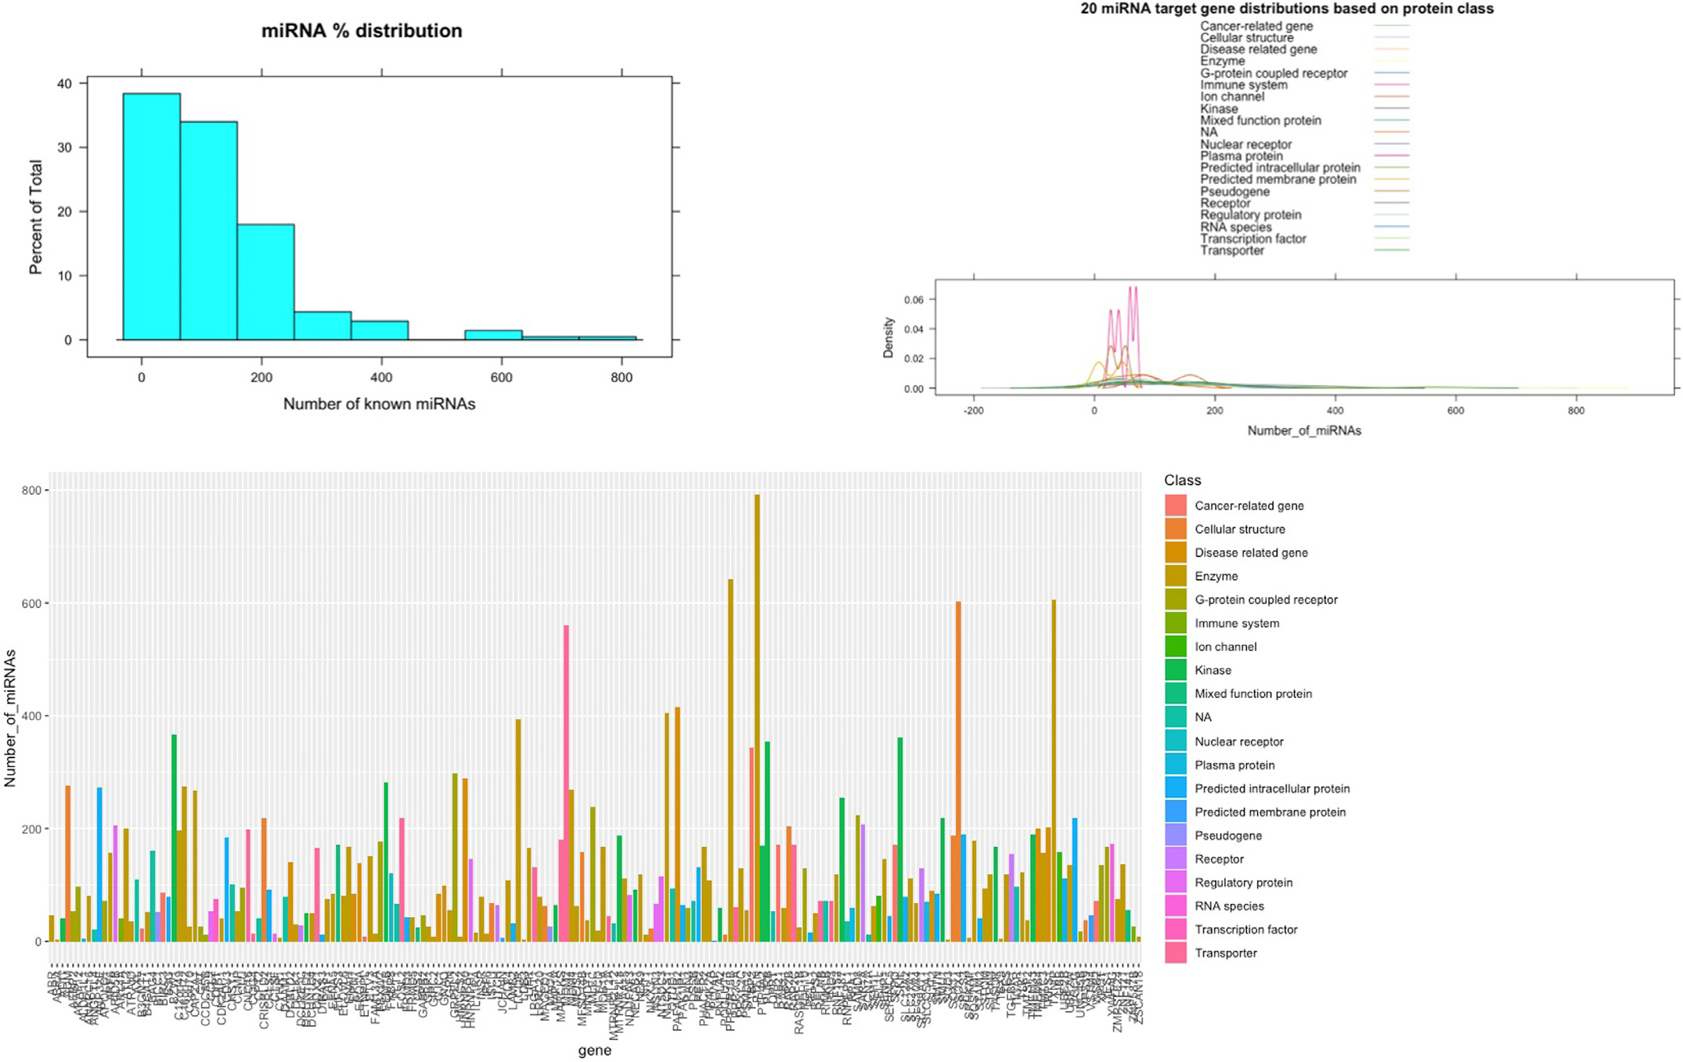

**Fig.17.**ValidatedmiRNAsummaryexampleswheredistributionprofilesareshownfordifferentgenesandtheircorrespondingproteinclasses.Summarydensity plotsandhistogramsarealsoshownfordifferentparameters.

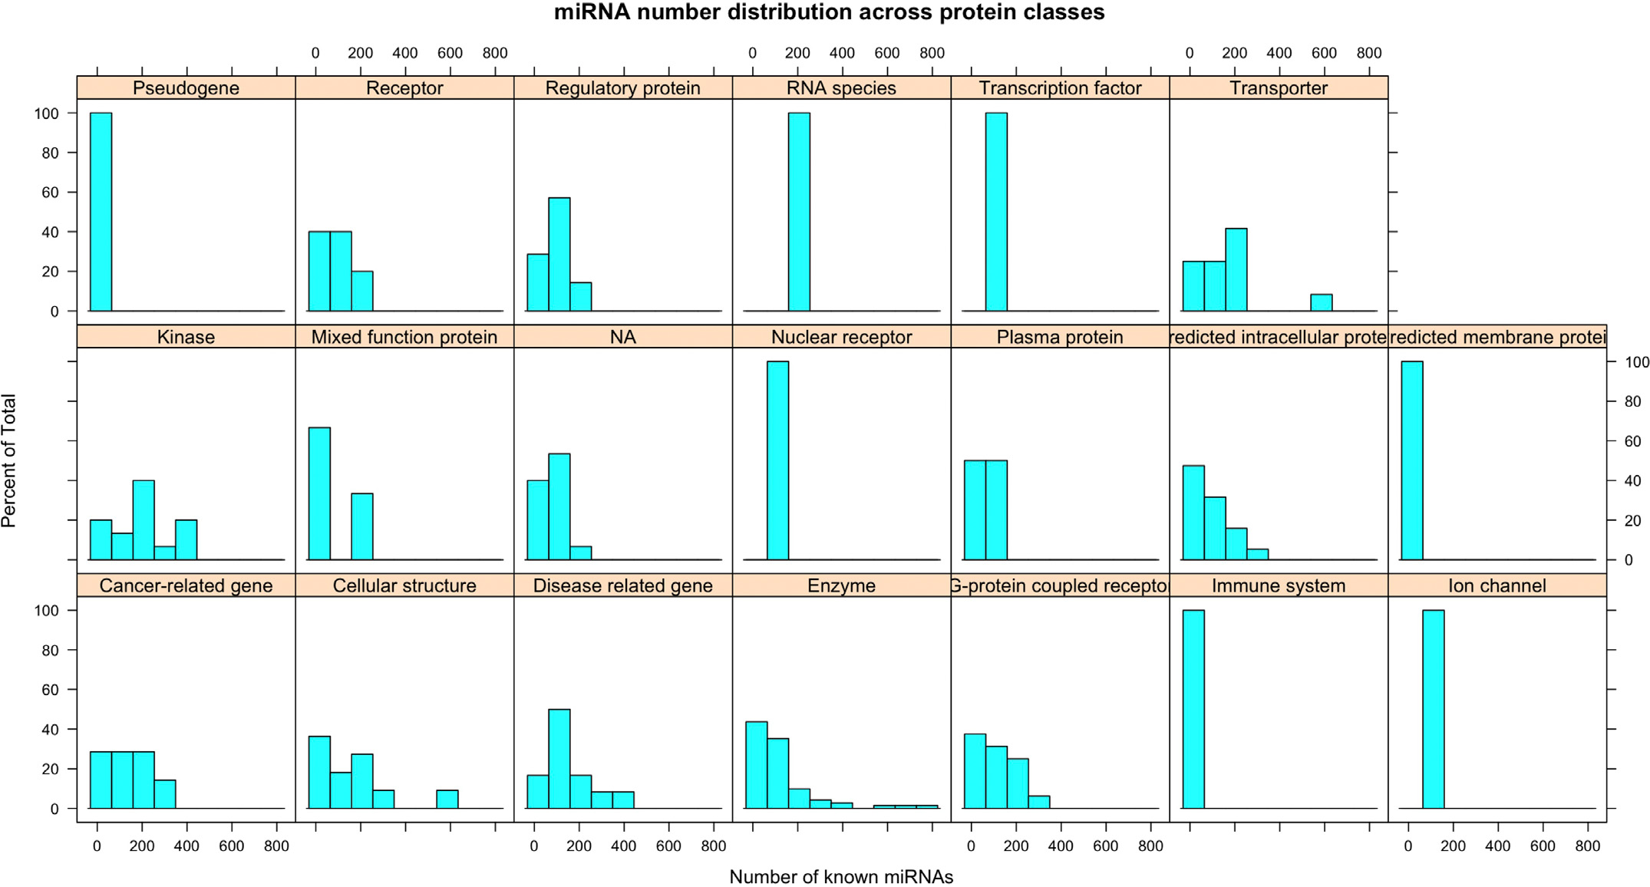

**Fig.18.**ValidatedmiRNAsummaryexampleswheremiRNAcontentdistributionisshownfordifferentproteinclasses.

13

*A.Kanapeckaite*  *ArtificialIntelligenceintheLifeSciences1(2021)100025*

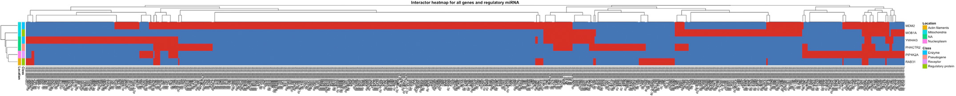

**Fig.19.**miRNAnetworkplotexamplewheregenesandmiRNAsaremappedusingaheatmapsothatsharedlinksarehighlightedinred.(Forinterpretationofthe

referencestocolorinthisfigurelegend,thereaderisreferredtothewebversionofthisarticle.)

ThedevelopedscoringfunctionsandGMMpipelineenablesexhaus-tiveanalysisoftheexpressomeandtheassociatedinteractomecom-plexity.Theautomatedprocessingtakescareofthemachinelearning modeloptimisationmakingthisanalysiseasilyadaptabletoindividual researcher’sneeds.Theimplementationofprobabilisticmodellingcre-atesopportunitiesfornewinsightsbasedongeneexpressionchanges, diseaseassociations,andthesizeofthenetworkforaspecificgene.Ex-tractingthisinformationcanestablishrelevantseedpointstorecreate complexsignallingpathwaysorusethisdatatoselectgenesthatshould besubjectedtodownstream*invitro*studiesensuringthatadiversese-lectionismade.

Inaddition,advancedfunctionsforepigenomicsanalysispermitthe explorationoftheepigeneticregulatorylayer.Thismightbeveryhelpful whenidentifyinggenesthatmaydependonepigenticregulation[19]. Specifically,ifaCpGislandcontaininggenechangedexpressionduring treatmentordiseaseprogression,itmightsuggestthatthereisanepige-neticcomponentcontrollingtheexpressionlevels.Similarly,exploring agene’smiRNAnetworkcouldhintatotherinteractinggeneswhich mightnothavebeenpickedupbythedifferentialexpressionanalysis orhelpprepareforRNAinterferencestudies.Moreover,miRNAinterac-tomeanalysisprovidesthefirstin-depthlookintowhatgenesarecon-trolledbythesamesetofmiRNAs.

Additionalfunctionalitiesofthepackagecreateananalyticalenvi-ronmenttosummarisegenefunctionalclassesorinferwhatcellular compartmentsaretypicallyassociatedwiththegene/protein.Suchas-sessmentsinthecontextofexpressionchangesordiseaseassociationcan highlightemergingpatternsinspecificcellularstatesundertheinvesti-gation.Aspeciallydesignedfunctiontoextractgenepatternprofilescan aidinafurtherrefinementofcausalgenenetworkswhenconsideringa specificphenotypeoracondition.

Thus,*OmicInt*offersacomprehensive,evolving,andadaptableplat-formforgeneexpressionanalysisinthecontextofthetranscriptome, proteome,andepigenome.Theanalysesaremadefreelyavailabletoall researcherswherefurthercontributionsandalgorithmicdevelopment arealsomadepossible.

**DeclarationofCompetingInterest**

Theauthordeclaresnoconflictofinterestregardingthepublication ofthemanuscript.

**Supplementarymaterials**

Supplementarymateri[alassociatedwiththisarticlec](https://doi.org/10.1016/j.ailsci.2021.100025)anbefound,in theonlineversion,atdoi:[10.1016/j.ailsci.2021.100025](https://doi.org/10.1016/j.ailsci.2021.100025).

14